# Task C1.2.2

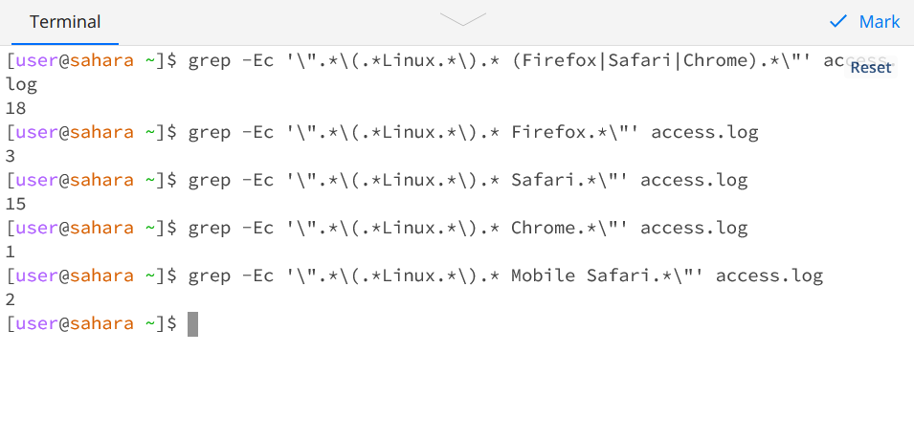

Total Linux Users: 18

Out of that,

Total Firefox users: 3

Total Safari users: 15 (including Mobile Safari)

Total Chrome users: 1

Total Mobile Safari users: 2 (including one chrome user)